# Eclipse configurations

## Jboss server configuration

Download jboss server from the following website.

<http://www.jboss.org/jbossas/downloads/>

The server we are using for all bizcapps projects is 7.1.1 final version. So download only 7.1.1.

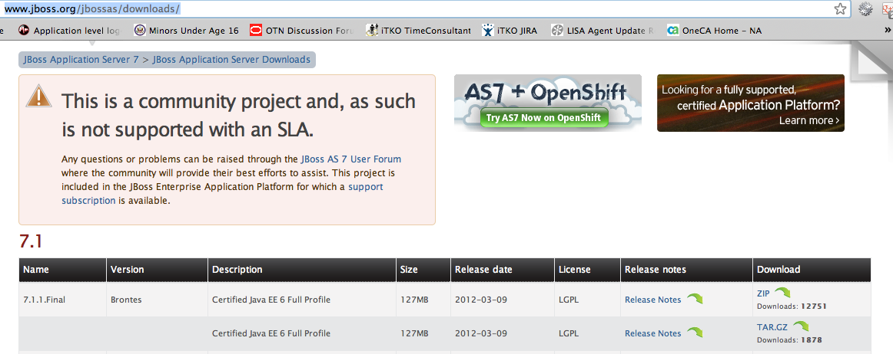

## Plugins

### Adding JBoss tools plugin.

Step 1: Click install new software under eclipse Help menu

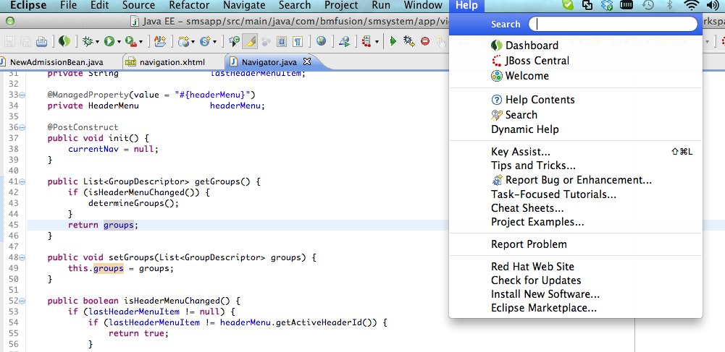

Step 2: Click on Add button

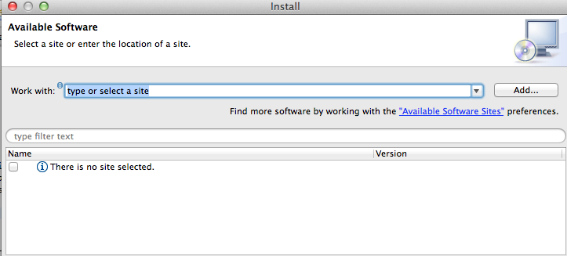

Step3: Add JBoss tools repository and click ok

Location: http://download.jboss.org/jbosstools/updates/development/indigo

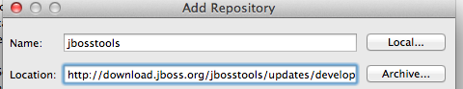

Step4: Now select JBoss tools as shown below and click next and follow eclipse instruction to complete installation..

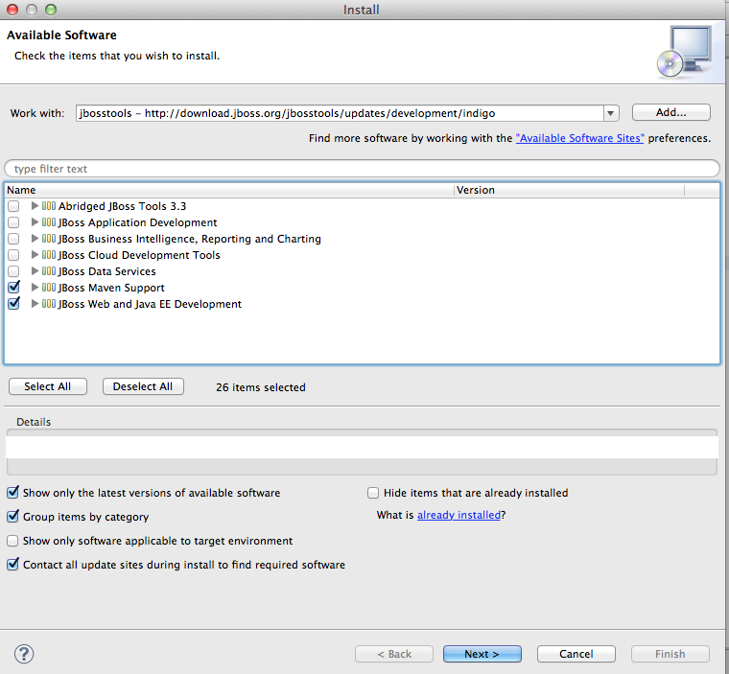

## Save actions

Step1: Go to eclipse preferences.

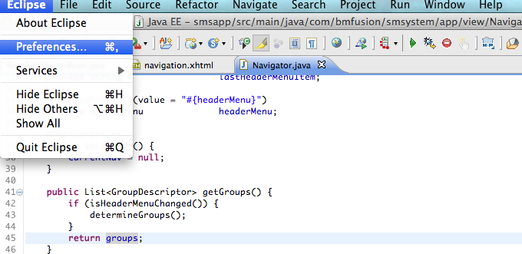

Step2: Type filter text as save actions and select save actions under Java editor.

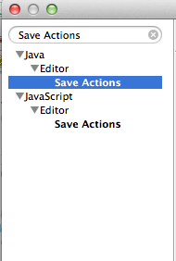

Step3: Check the check boxes and radio buttons as shown in the below figure and click configure button.

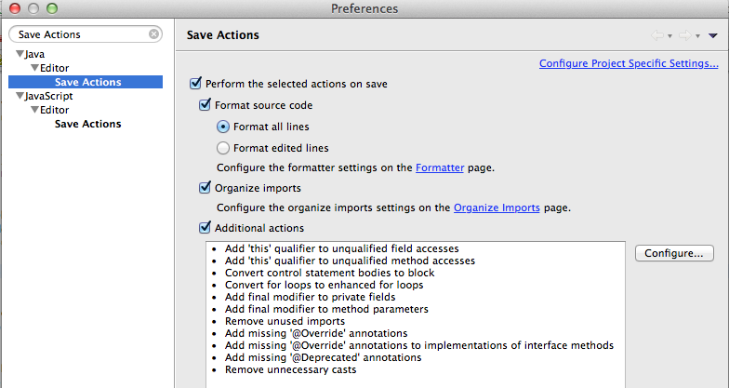

Step4: Under additional save actions settings follow the configurations as shown in the following figures.

Code organization tab

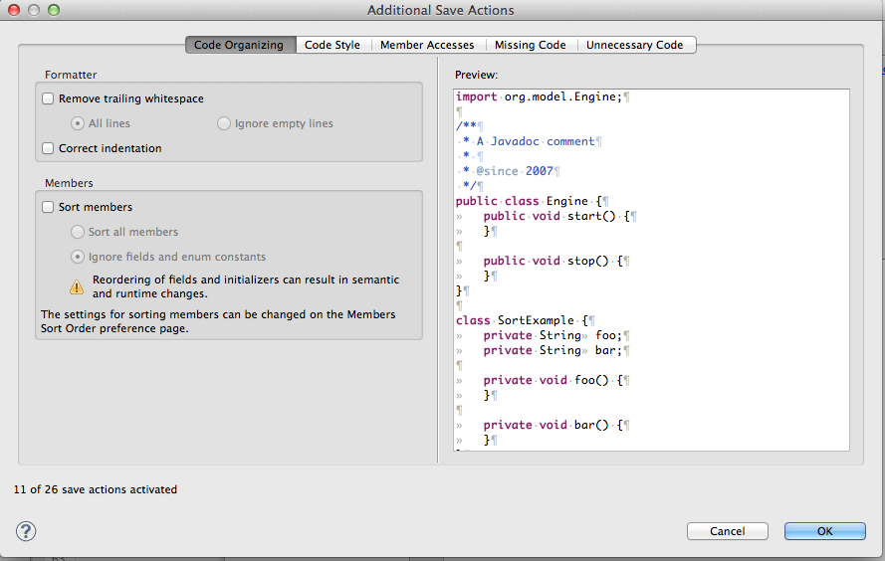

Code style tab

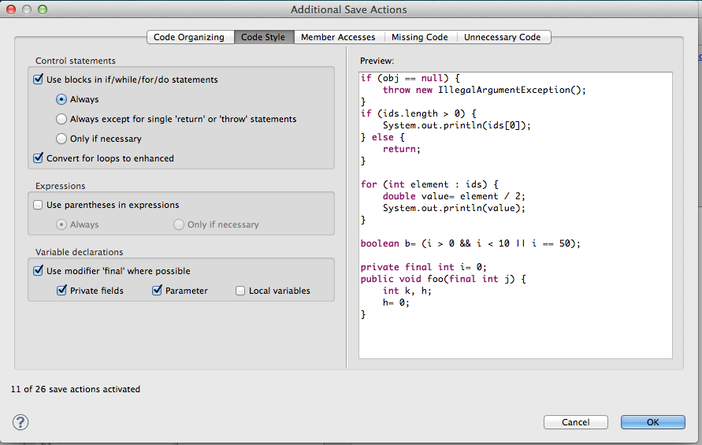

Member accesses tab

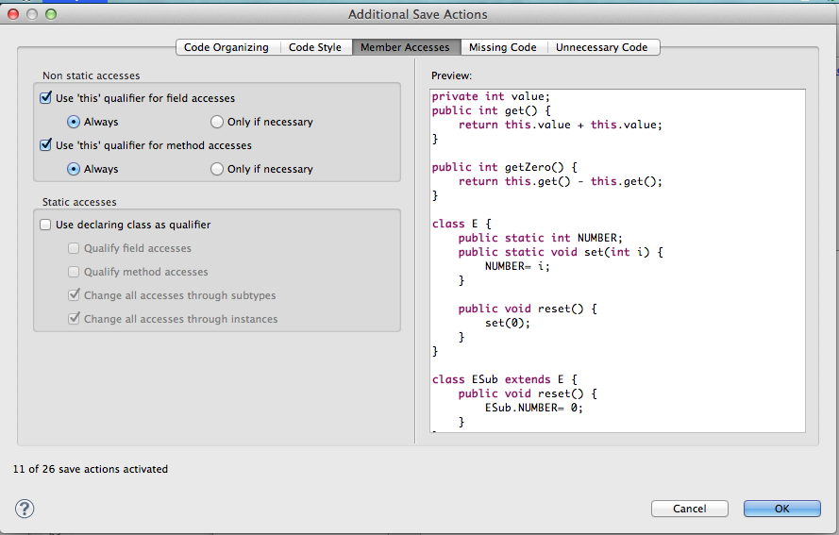

Missing code tab

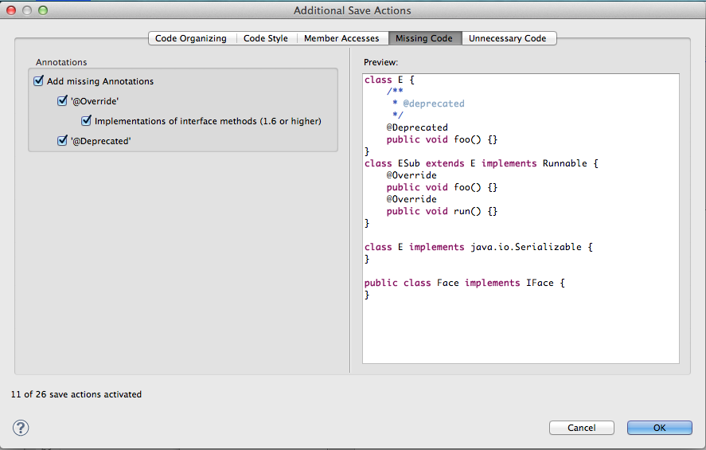

Unnecessary code tab

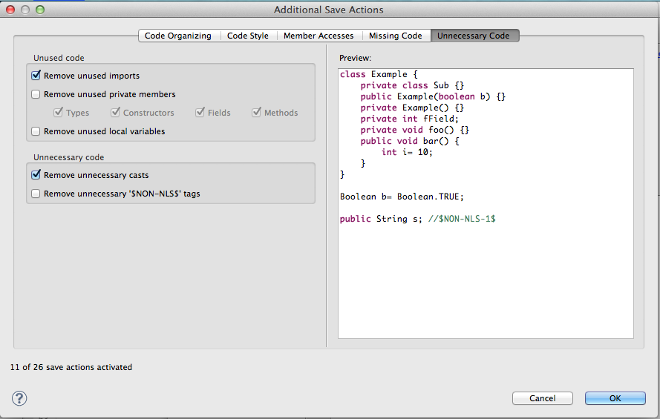

Now say OK on both Additional save actions and Preferences.

### Formatter

Maximum Line Width :

Ant :

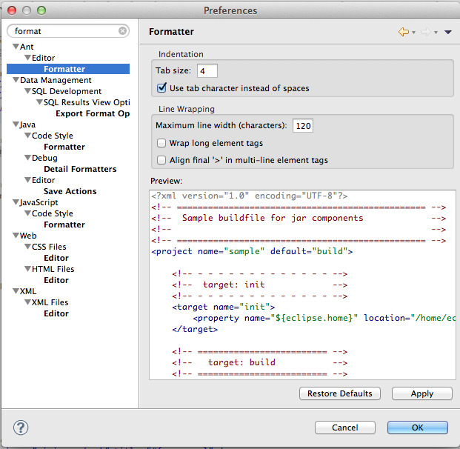

Css Files

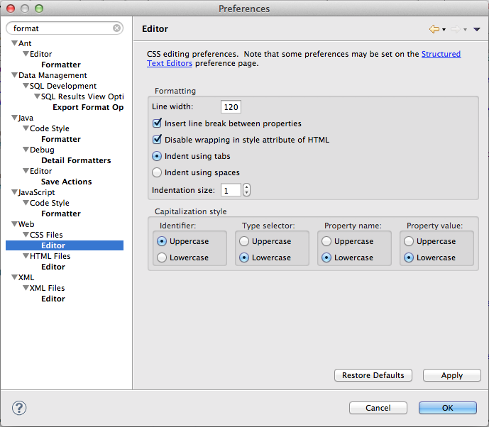

HTML Editor

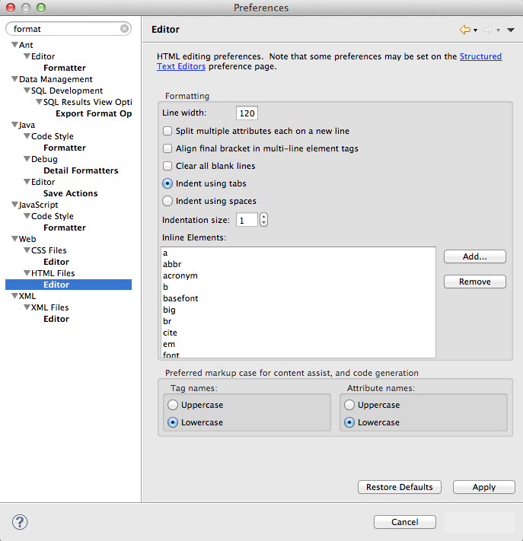

XML Editor

